**Project Report**

**on**

**ELECTRISTAIRS**

***Submitted in partial fulfilment of the***

***Requirements for the award of the degree***

***of***

BACHELORS OF ENGINEERING

in

MECHATRONICS ENGINEERING

**Submitted By: - Faculty Supervisor: -**

SUDEEP YADAV (Project lead) Mrs. JASPINDER KAUR

UID : 19BEM1027



**UNIVERSITY INSTITUTE OF ENGINEERING**

**CHANDIGARH UNIVERSITY**

**GHARUAN, MOHALI, PUNJAB, INDIA-140413**

**2021**

|  |  |  |
| --- | --- | --- |
| **INDEX** | | |
| **Sr. No** | **Content** | **Pg. No** |
| 1 | ABSTRACT | 3 |
| 2 | INTRODUCTION | 3 - 4 |
| 3 | OBJECTIVE | 4 |
| 4 | LITERATURE REVIEW | 4 |
| 5 | OVERVIEW   * Working Procedure * Architecture | 5 - 9 |
| 6 | THEORITICAL CALCULATION | 10 |
| 7 | REQUIRED ELEMENTS | 11 – 14 |
| 8 | EQUIPMENTS / TOOLS NEEDED TO COMPLEATE THIS PROJECT | 15 - 16 |
| 9 | Approximate Cost of project | 17 |
| 10 | Work plan and work distribution | 18 |
| 11 | PENDING WORK | 19 |
| 12 | CONCLUSION | 19 |
| 13 | ACKNOWLADGEMENT | 20 |
| 14 | REFERENCE | 21 |

**ABSTRACT:**

As we all currently use non-renewable energy sources like coal and petroleum as well as renewable sources like solar, wind, hydro, geothermal, etc. for electricity generation but still, we couldn’t overcome our power needs. Each new day, the need for electricity is growing rapidly. And the state has arrived when we have to think of generating electricity in each and every possible way. Also an increased environmental awareness is growing and there is a great need for efficient and productive designs to involve in our daily routine. The world has embraced this concept by incorporating solar panels, wind turbines, and promoting this limited type of energy source via zip cars. We looking for new ways to generate energy, we will be focusing on harvesting energy from everyday activities which are also eco-friendly and good for nature. Our project Electristairs which is a staircase power harvesting system chooses to turn the energy which is wasted while climbing stairs into electrical power using a Gear Mechanism and piezoelectric generators.

**INTRODUCTION:**

Our project attempts to show how energy can be generated from a commonly used stair step. The usage of steps in whole world's building is increasing day by day. Even a small building has more than one floor. While climbing upstairs, we found that a lot of human energy gets wasted when we are stepping on the floor by the waste of heat and friction, we can harvest it rather than simply letting it go. there is a huge possibility of collecting this energy and generating power by making every staircase as Electristairs. The utilization of waste energy of human foot power is very much relevant and important for populated countries like ours (India). Our project Electristairs focuses on the same. By the means of Electristairs we are trying to harvest the energy in two ways, one is the gear and motor arrangement mechanism that takes the staircase power and converts the power to an electrical source, and the other one is a piezoelectric generator that harvests mechanical vibrations energy available on a Staircase. The generated power then can be stored in batteries or we can use an inverter circuitry and use it as convention electricity at our household plugs which has an output of 220 volts. The generated electricity will be totally free of cost and it will be used as per our own needs and purposes. It’s free of cost eco-friendly energy which is easily useable and as far as we know this is a non-conventional power generation system when we compared it with the existing systems.

**OBJECTIVE:**

We are trying to capture energy from the everyday motion of people who are traveling up and down with help of a staircase. Our method generates electric power without polluting environment and is very efficient for use in urban areas. The energy which is wasted by humans while using staircase is utilized in our system and is delivered as output. The energy source is continuous and renewable. Moreover, we are confident that this method of electric energy generation will be used for rural electrification and to fulfil the growing power needs of the world as well. Also, this system is very eco-friendly from an environmental point of view. Our main goal is to collect as much energy as we can, without compromising the reliability and safety of traditional stairs.

**LITERATURE REVIEW:**

* An investigation on generation of electricity using foot step 2015 by Siba brata Mohanty, Sasank Shekhar Panda, Rayagada, Odisha. The motive of this work is power generation through footsteps.It is based on the crank shaft and gear arrangement and fly wheel.
* Design of energy capturing medium using piezoelectric effect by S. Krishna (2015).
* Proposed Method of Foot Step Power Generation Using Piezo Electric Sensor by Mr.A.Adhithan, K.Vignesh, M.Manikandan (2015).
* Staircase Power Generation Using Piezo-Electric Transducers, November 6,2013 Produced by V. Prasannabalaji, R. Rakesh, S. Sairam and S. Mahesh from Electronics and Instrumentation Engineering, Sri SaiRam Engineering College, Chennai. They generate power through piezoelectric materials being a non-conventional approach, helps to reduce the pollution.
* Piezoelectric power scavenging of mechanical vibration energy by U.K. Singh and R.H. Middleton (2007)

**OVERVIEW:**

**WORKING PROCEDURE:**

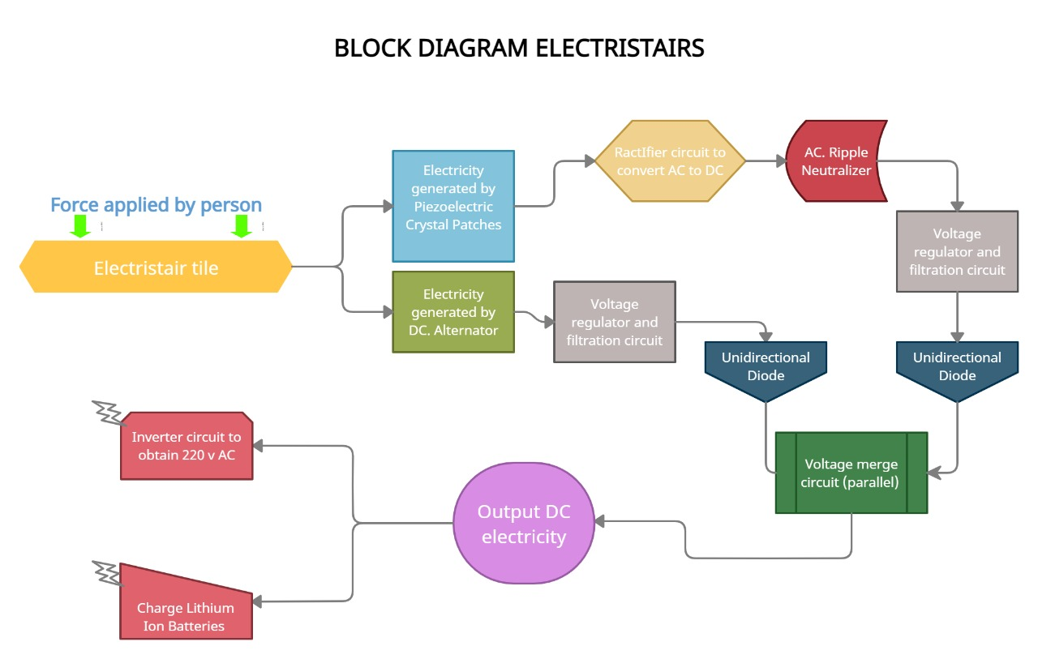As we mentioned earlier in this paper, we plan to harvest energy from the everyday motion of people and we want that the energy supplied by humans should be utilized in some form rather than wasting it entirely. So, we made Electristairs. Our Electristairs project generates electric power without polluting our environment and so is very eco-friendly from an environmental point of view. The possibilities are endless and our system does not limit the user’s usage. Below we have shared the BLOCK Diagram of or project to depict how the entire system will work.

We are using here two merged method for harvesting the waste human power.

1) Piezoelectric crystal patches/ plates.

2) Alternator with gear arrangement mechanism assembly.

Piezo electric crystals are said to give an output of about 13 volts on an average but after performing experiment practically we found that each piezoelectric plate was providing around 1.3-1.5 volts after the entire processing with sufficient amount of current. so as our project is having 24 individual piezo electric plates so we divided them into pair of 2 where each pair will be interconnected in parallel combination resulting in 12 pairs yielding about 15 - 18 volts as output. We rectify it and pass it through a ripple neutralizer because piezoelectric plates produce AC outputs. Then we pass this voltage through a voltage regulator and filtration circuit which regulates the output voltage to 12 volts and soothes the output preventing it from voltage spikes or fluctuations.

An alternator acts as a second source of produced electricity and it produces directly in DC form. On an average, a dc alternator produces DC output of about 13-15v but with high current, much higher than piezoelectric plates. Our special gear mechanism assembly pays a very vital role here. It’s working mechanism is such that irrespective of a push or a pull, it always turns the rotor of the alternation in one direction only. Resulting in continuous dc output. (images to explain the working of mechanism are shown below:)

🡪

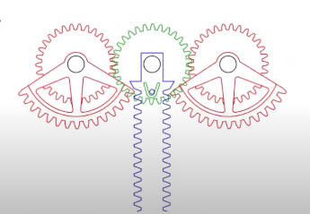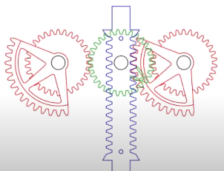

🡪

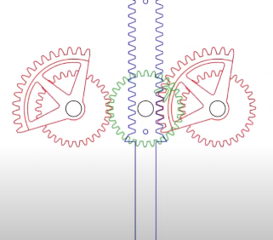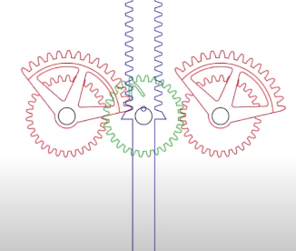

🡪

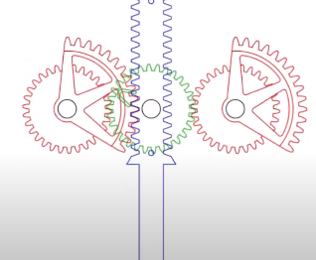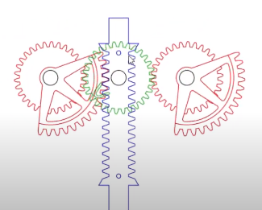

3D model🡪

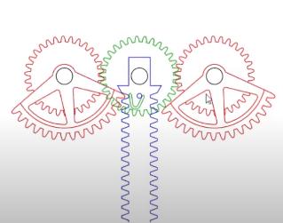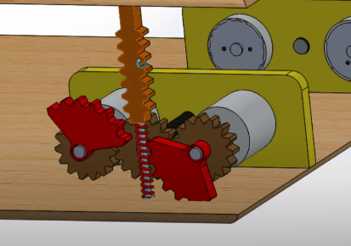

After that, we regulate the output voltage to 12v as we did earlier by using a voltage regulator and filtration circuit and hence we get clean smooth 12 v output.

So now we have 12 volt output from 2 sources one from piezoelectric and the other from DC alternator then we merge both of these 12 volts from different sources together my using a merging circuit and hence as a result we get a clean output voltage of 12 volts with sufficient amount of current which can further be used in any form of electricity.

We are by default adding 2 options for the user to use the output from Electristairs, one is 12 volt DC direct which will be available in a DC jack and the other option is by having an inverter circuitry. This inverter circuit will convert from 12v volt DC to 220 volts AC, (same as our home invertors work) allowing the user to connect all 220 v electronics like laptop chargers, phone chargers battery charger modules etc. to work for free, at 0 cost of electricity

**ARCHITECHTURE AND CONCEPT DESIGN 3D MODEL:**

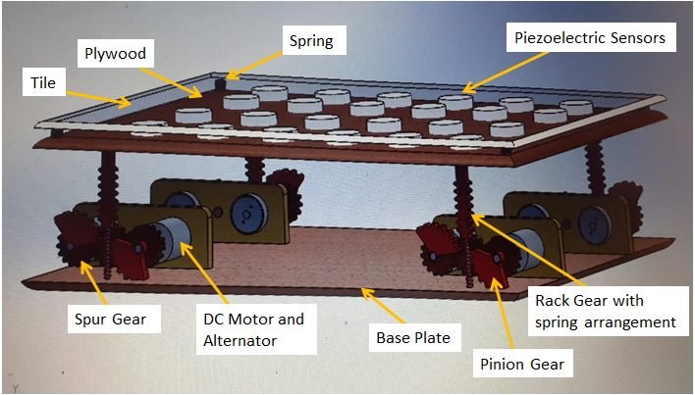

Here we have the Electristair tile (where we give the load) on the upper portion bellow that we use piezoelectric sensor between one more plate, bellow that plate we using the gear arrangement mechanism. In this gear arrangement mechanism, we have rack and pinion gear and spur gear. The lower end of the rack has the spring, and below the spring we have the base plate. With the gear arrangement, there have a DC motor & alternator for collecting the electrical energy from the mechanical energy. From here, operating the further process we have two setups for collecting the electrical energy.

One, is from the piezoelectric sensor, going to the rectifier for converting the current from AC to DC. After that, it is going through the AC ripple neutralizer to the voltage regulator. There have also a filter circuit. Then there has a unidirectional diode for transfer the voltage into the voltage marge circuit.

Another one is from alternator produced electrical energy going to the voltage regulator and filter circuit. Then there also has a unidirectional diode for transfer the voltage into the voltage marge circuit. From the voltage merged circuit, voltage is stored into the given lithium batteries or into the 220v Inverter.

**THEORITICAL CALCULATION:**

One Piezoelectric sensor given electric energy= 1.3-1.5 volts

1 pair having 2 each connected in parallel give = 1.3 volts but with more current

12 such pairs as there are 24 in total will give us = around 15 volts when connected in series

(Then we regulate the output to 12 volts by using a voltage regulator)

On the other hand we have,

8 DC Alternators connected in parallel gives = Around 13 volts but with high current.

(Then we again regulate the output to 12 volts by using a voltage regulator)

So, now we got 12 volts each form 2 source. After getting this amount of voltage we marge it in parallel combination and hence we get a constant output of 12 volts with sufficient amount of current.

As per our assumption= one step will produce 12 volts which is able to light up a 3 x 4 matrix led panel for about 10 seconds because the capacitors in the filtration circuit will store some charge and release it gradually. So just imagine the amounts of steps on a single electristair tile if it is placed in any building like an institute or a university full of thousands of children. Each day Electristair will encounter thousands of steps and we can generate enormous amounts of electricity just from staircases.

**REQUIRED ELEMENTS AND PARTS LIST:**

GEAR ARRANGEMENT

In this project we are using spur gear with rack and pinion arrangement along with: springs, rods, alternator holder clamp, stair tile, and stair base. When stair will be pressed due to someone’s weight while climbing up the stairs then rack will be pushed down which will simultaneously press spring which is connected at it’s bottom and the teeth of rack will mesh together with those of pinion gears which have approx. half circumference of teeth, enabling the rotor of alternator to rotate in clockwise direction. Once the rack is fully pressed and reaches the bottom, now the real magic of this assembly happens. At present the spring is at it’s full compression , so when someone lifts up his foot from stair spring reverses the rack back to it’s original position but 2nd pinion gear starts to mesh turning the rotor of alter again in clockwise direction rather than anticlockwise.

Hence, in short, the gear mechanism allows the **motor to rotate in one direction** **only** irrespective of we push down or pull up the stair tile of Electristairs, which as a result produces enormous amount or electrical energy because there are **4 such gear assemblies and 8 DC Alternators..**

PIEZOELECTRIC CRYSTAL:

Piezoelectric crystal plates or patches are placed in the gap between the top plate and the intermediate tile and are used to convert the mechanical energy into electrical energy by the means of Piezo-electric effect. **Piezoelectric Effect** is the effect due to which some materials generate an electric charge in response to applied mechanical stress. They are mainly used as sensors of pressure or force for research and development in various industries. The applications of this sensor involve, aerospace, medical, nuclear instrumentation, and as a pressure sensor it is used in the touch pad of mobile phones. In basic terms, they are actually transducers, because they convert energy from one form to another (in this case from mechanical to electrical).



DC- ALTERNATOR:

A DC Alternator is an electrical energy generator, that converts mechanical energy to electrical energy in the Direct Current form. the rotary motion of the shaft of the alternator produces electricity as an output, and in our project we are converting linear to rotary motion to achieve the desired output electricity.

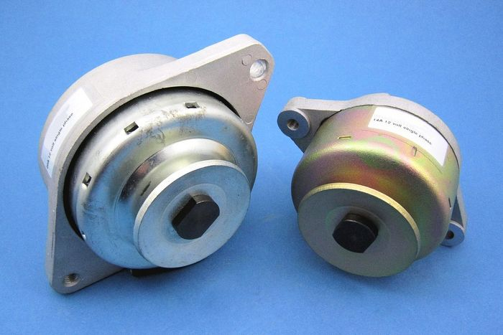

RECTIFIER:

A Rectifier is an electronic circuit that converts Alternating Current (AC) to Direct Current (DC) at its output.

The process is known as rectification since it will "straighten" the direction of the current.

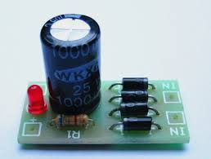

AC RIPPLE NEUTRALIZER:

A Ripple Neutralizer is a device that is used to remove the ripples from the output of the rectifier and smoothens the output wave which is received from the filter, and it is constant up to the load and main voltage remains constant. Though, if any of the two is varied, then the received DC voltage at this point will change. For that, a regulator is applied to the output stage.

7812 VOLTAGE REGULATOR:

A Voltage Regulator is an electronic device which maintains a constant output voltage at a certain level. For example; a 12 volt voltage regulator will always deliver constant 12 volt as output if the input provided varies between 12 -20 volts. It uses a simple feed-forward design or a negative feedback loop system.

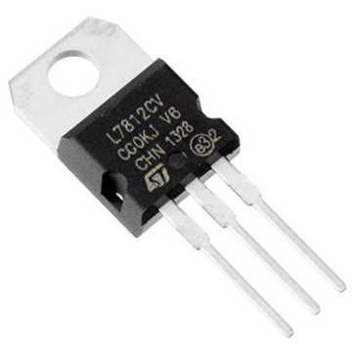

FILTRATION CIRCUITRY:

The ripple in the signal denotes the existence of some AC component. This AC component will completely remove for to get pure DC output. So, we have to build a circuit that smoothens the rectified output into a pure DC signal. Most of the filtration circuits include capacitors and some basic electronic components.

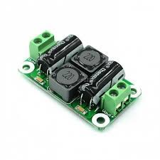

UNIDIRECTIONAL DIODE:

A Diode is a simple semiconductor electronics device that basically acts as a one-way switch for current. It allows current to flow easily in only one direction, but mortally oppose the current from flowing in the opposite direction.

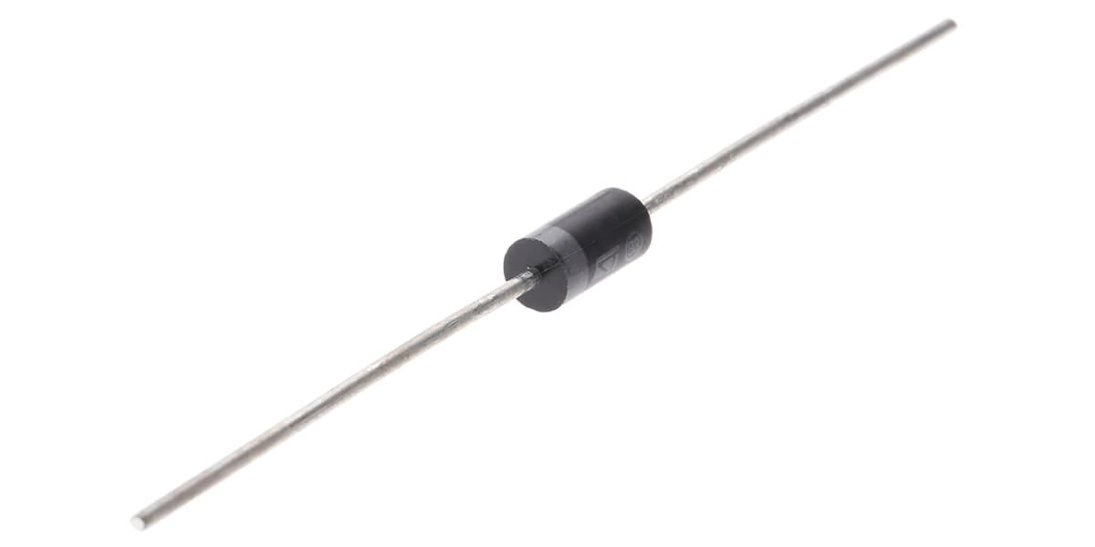

MERGED CIRCUIT:

As we are taking the voltage from the piezoelectric method as well as from gear mechanism, so we require to merged them in parallel combination. This is done by the merge circuit.

DC CONNECTOR PLUG:

This plug will be at the last after the whole process gets completed. It is used so that user can directly use 12 volts DC if he wants to use it somewhere. For example: for charging batteries for other DC applications etc.

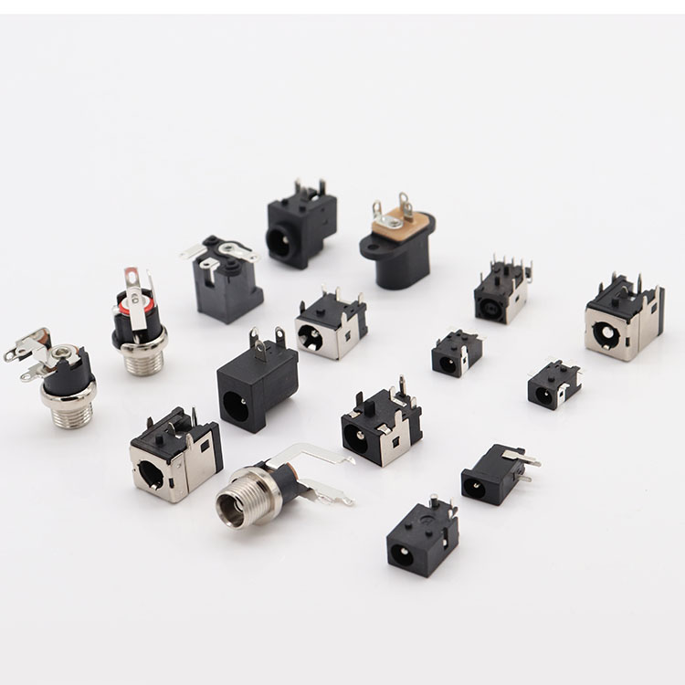

CONNECTING WIRES:

Wires are necessary part of every system and they are used for electrical connection between various electronic devices.

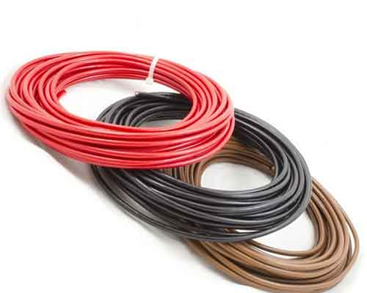

**EQUIPMENTS / TOOLS NEEDED TO COMPLEATE THIS PROJECT**

**1) -Soldering Iron**

**-Soldering Flux**

**-Soldering Wire**



**2.) Dreamel tools and Dreamel 3000**



**3.) 2 Part Epoxy Resin Super Glue**



**4.) Other Miscellaneous materials like nuts, bolts and screws**

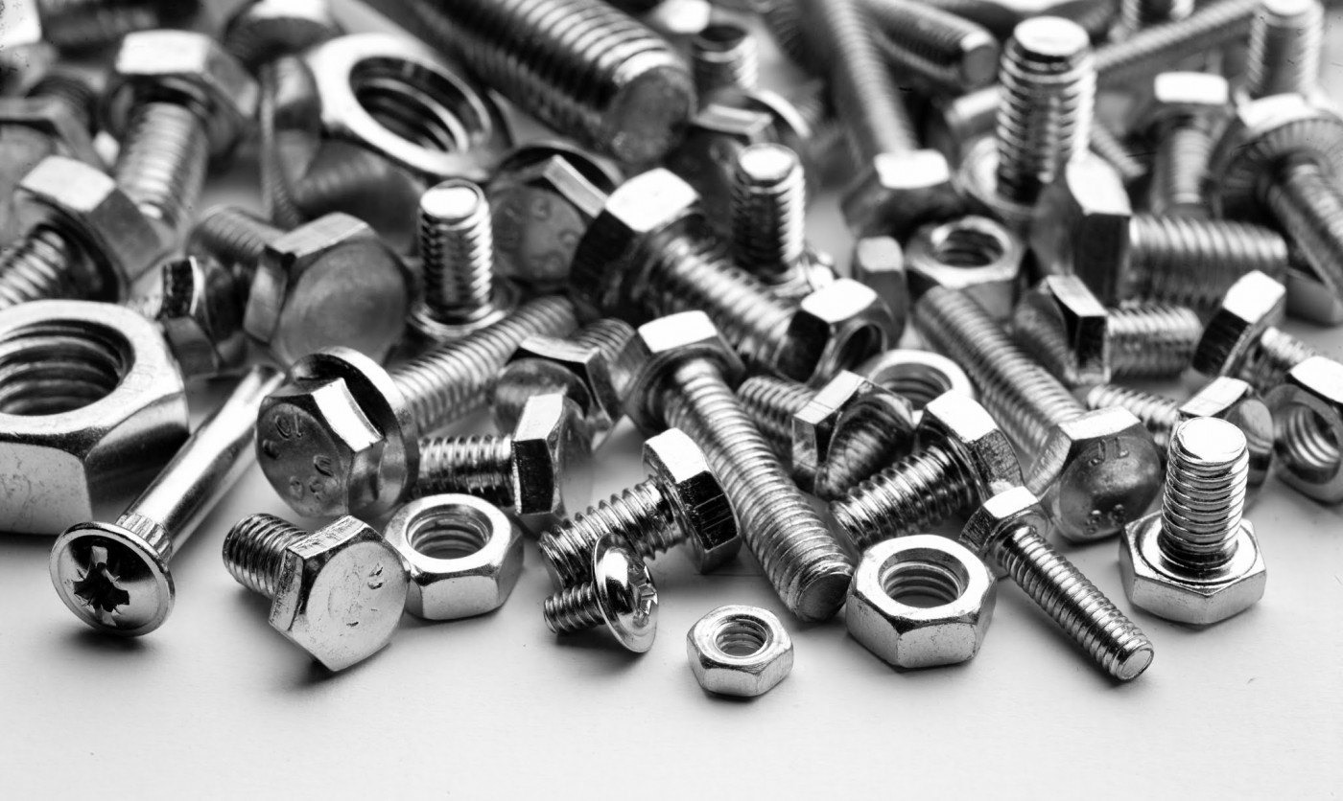

**Approximate Cost of project:**

GEAR MECHANISM ASSMBLY 1 x 800 = 800

PIEZOELECTRIC CRYSTAL PATCHES / PLATES: 8 X 24 = 192

DC- ALTERNATOR: 200 X 8 = 1600

RECTIFIER: 1 X 50 = 50

AC RIPPLE NEUTRILIZER: 1 X 80 = 80

7812 VOLTAGE REGULATORS: 2 X 10 = 20

FILTRATION CIRCUITRY: 2 X 50 = 100

UNIDIRECTIONAL DIODE: 2 X 5 = 10

MERGED VOLTAGE STORAGE: 1 X 20 = 20

DC JACK: 1 X 20 = 20

CONNECTING WIRES: 100 RS (APPROX)

**TOTAL COST 2992 Rs or Rs 3000 (approx.)**

**Work plan and work distribution:**

* Every team member has equally participated and contributed towards the making and implementation of this project toward success.
* However, **Sudeep** came up with excellent Idea of Electristairs and also helped the team by providing some 3D visualization for the various parts.
* **Preetinder** helped the team by providing all the technical knowledge for improved structure and design of the Electristairs and lead the team for this project.
* **Shashwat** provided the required calculation for better efficiency and output of the project along with some minor detailing and presentation.
* All the theoretical help was provided by **Sankhyadip** which include important articles related to the topic and other content like YouTube videos and all.

**PENDING WORK:**

As we all know, whole world is facing COVID-19 situation. So it would not be possible for us to meet and give the project its final touch. So as per the situation we have made our project with the simulation part only. Further we will update it as a realistic version. Also, we will try increase the efficiency and effectiveness of the mechanism to collect more electrical power from human energy. We also look forward to implement our Electristairs in crowded places like university campuses, subways/ metro stations, railway stations community buildings etc. in coming few years.

**CONCLUSION:**

Our Electristairs project generates clean and eco-friendly electrical energy without compromising the reliability and safety of traditional stairs. We trap the energy of people which is being wasted while using the stairs and after it’s processing which we showed in block diagram, we get smooth 12 volts output from Electristairs which can be utilised as per needs. The energy source form each stair is continuous and renewable. Moreover, we believe that this method of power generation will be used for rural electrification and to fulfil our power needs of future cities. We are looking forward to place our Electristairs at busy places such as university campuses, railway stations, bus stations, and the major substations where people make lots of crowds while they use to go up and down through the staircase. This approach will provide a lot of free generated electricity to consumers and full their daily requirements like travelling on electric scooters, charging batteries, lighting up corridors etc.

**ACKNOWLEDGEMENT**

It gives me proud privilege to complete this mid semester project. This is the only page where we have the opportunity to express my emotions and gratitude. It is great pleasure in expressing sincere and deep gratitude towards my supervisor and guide Mrs. Jaspinder Kaur for her valuable suggestions, guidance, and constant support throughout the completion of this project named “Electristairs”. I am really very thankful to Chandigarh University for providing me such a great opportunity to make such a wonderful project which can solve real-life problems and extremely valuable hands-on experience along with crucial soft skills such as working in a team, communication skills, and much more. I also offer my most sincere thanks to every team member of our group who was working rigorously on this project and staff members of the Mechatronics Department, University Institute of Engineering, Chandigarh University for cooperation provided by them in every possible way.

SUDEEP YADAV Date: 7th MAY, 2021  
 (Group 5 Lead, student BE. Mechatronics)

**REFERENCES:**

[1Power Generation Using Foot Step 2011 v.Jose Ananth Vino, AP, Bharath University .

[2] Staircase power Generation Using Piezo-Electric Transducers 2013V. Prasannabalaji, R.Rakesh, S. Sairam and S. Mahesh Electronics and Instrumentation Engineering, Sri SaiRam Engg College, Chennai.

[3] Electricity generation from Footsteps 2010 S.S.Taliyan, B.B. Biswas, R.K. Patil and G. P.Srivastava Reactor Control Division, Electronics & Instrumentation Group and T.K. Basu IPR,Gandhinagar

[4] An investigation on generation of electricity using foot step 2015 Siba brata Mohanty, Sasank Shekhar Panda, Research scholar, Department of Industrial Engineering, G.I.E.T, Gunupur

[5] Power Generation from Staircase (Steps) 2014 Ramesh Raja R1, Sherin Mathew, UG Scholars, Department of Mechanical Engineering, RVS College of Engineering & Technology Dindigul, India

[6] Electricity Generation from Footsteps; A Regenerative Energy Resource 2013 Tom Jose V, Binoy Boban, Sijo M T SCMS School of Engineering and Technology, Kochi

[7] Power Generation Footstep 2014 Shiraz Afzal, Farrukh Hafeez Electronic Engineering Department, Sir Syed university of Engineering and technology, Karachi, Pakistan; Electrical and electronic engineering Department, Jubail Industrial College, Jubail, Saudi Arabia.